
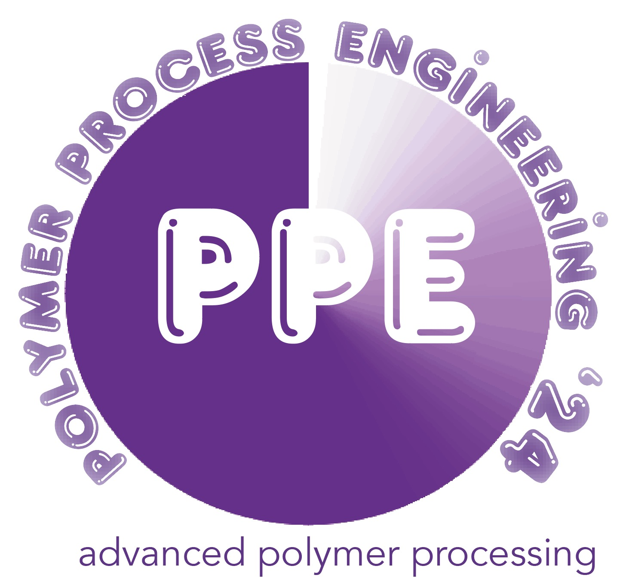








 |  |  | Monday 8 January
 |  |  | Lecture Theatre D4 & Atrium, University of Bradford
 |  | 10.00 | Registration
 |  |  | Polymer IRC, University of Bradford
 |  | 11.45 | Lunch
 |  | 12.45 | Welcome
 |  |  | Pharmaceutical and Medical Technologies 1
 | SKM1 | 12.50 | Correlation of formulation structure in vivo and in vitro
 |  |  | Jiwen Zhang, Shanghai Institute of Materia Medica Chinese Academy of Sciences
 | IM2 | 13.15 | Interdisciplinary approach for commercialisation of cocrystal based technology
 |  |  | Anant Paradkar, Pharmaceutical Engineering Science, Polymer IRC, University of Bradford
 | M3 | 13.30 | Delivery of Biomacromolecular Drugs with Biomaterials
 |  |  | Jun Wang, South China University of Technology
 | IM4 | 13.40 | Development of fluorophore and bioconjugate technologies for cancer research and drug discovery applications
 |  |  | Klaus Pors, ICT, University of Bradford
 | KM5 | 13.55 | The Role of Biodegradation in Regulating Biodegradable Polymeric Materials for Potential Biomedical Applications
 |  |  | Zhihua Gan, Beijing University of Chemical Technology
 |  | 14.15 | Coffee & Posters/ Exhibition
 |  |  | Pharmaceutical and Medical Technologies 2
 | KM6 | 14.45 | Leaving nothing behind: non-permanent medical devices for vascular disease treatment
 |  |  | Nial Bullet, Kadem Al-Lamee, Arterius Ltd
 | M7 | 15.05 | The value of experimental models in orthopaedic fixation
 |  |  | Tony Herbert, University of Leeds
 | M8 | 15.15 | Smart injectable hydrogels for controlled release drug delivery
 |  |  | Bana Shriky, Polymer IRC, University of Bradford
 | IM9 | 15.25 | Fiber scaffolds for tissue repair and regeneration
 |  |  | Jia Jia Xue, Beijing University of Chemical Technology
 | M10 | 15.40 | Multifunctional composites and nanotopographies for cell instructive and antibacterial implants
 |  |  | Maria Katsikogianni, Faculty of Life Sciences/ Polymer IRC, University of Bradford
 | M11 | 15.50 | Polymeric Skin Adhesion in Healthcare
 |  |  | Pete Twigg, Polymer IRC, University of Bradford
 | M12 | 16.00 | Application of Biomaterials to Treat Bacterial Vaginosis (BV)
 |  |  | Farshid Sefat, Polymer IRC, University of Bradford
 | M13 | 16.10 | Early career researcher ‘accelerator’
 |  |  | Zoha Salehi Moghaddam, Polymer IRC, University of Bradford, Production of biodegradable scaffolds by electrospinning for drug delivery for the treatment of breast cancer post-operatively
 |  |  | Ikechukwu Agbo, Polymer IRC, University of Bradford (extrusion co-crystallisation)
 |  |  | Alireza Ardestani, Danish Technical University. (precision processing)
 |  |  | Amir Zaernia, Faculty of Engineering & Digital Technologies, University of Bradford (AI for cancer diagnosis)
 |  | 16.30 | Laboratory Demonstrations, Polymer IRC
 |  | - 17.50
 |  | 18.15 | Tour of City Hall, Bradford
 |  | 19.00 | Banquet: City Hall, Bradford
 |  |  | Tuesday 9 January
 |  |  | Lecture Theatre D4 & Atrium, University of Bradford
 |  | 08.45 | Welcome
 |  | 9.00 | Strategy Session
 |  |  | Prof Li Guangxian - welcome
 |  |  | Prof Shirley Congdon, Vice Chancellor, University of Bradford
 |  |  | Mr Mingqin Ding, Minister Counsellor Science & Technology, Chinese Embassy
 |  |  | Prof Dujin Wang, ICCAS Beijing
 |  |  | Inc. Prof Yanjie Gao, Sinopec BRICI; PPS President; BPF President; Prof Li Guangxian/ Prof Phil Coates
 |  |  | Tribute to Prof Tom McLeish FRS
 |  | 10.00 | Group Photograph outside Richmond Building Entrance/ Coffee
 |  |  | Advanced Processing 1 - towards green processing
 | KT1 | 10.30 | Additive Manufacturing of Polymer Covalent Adaptable Networks
 |  |  | Hesheng Xia, Sichuan University
 | IT2 | 10.50 | Rubbers Crosslinked by Dynamic Bonds and Their Performance
 |  |  | Baochun Guo, South China University of Technology
 | IT3 | 11.05 | Strategies for high-quality 3D-printed elastomers
 |  |  | Xiang Lin, University of Science and Technology, Beijing
 | T4 | 11.20 | 3-d printing of TPVs
 |  |  | Michael Hebda, Polymer IRC, University of Bradford
 | IT5 | 11.30 | Stereo-complex PLAs
 |  |  | Adrian Kelly, Polymer IRC, University of Bradford/ Andy Gill, Floreon Transforming Packaging Ltd
 | IT6 | 11.45 | Biobased self-healing elastomers and their nanocomposites
 |  |  | Biqiong Chen, Queens University Belfast
 | T7 | 12.00 | Recycling rubbers using Solid State Shear Milling: understanding the chemistry of rubber recyclates
 |  |  | Rob Innes, Polymer IRC, University of Bradford
 | T8 | 12.10 | Biodegradable polyurethanes
 |  |  | Steve Rimmer, Polymer IRC/ Faculty of Life Sciences, University of Bradford (video)
 | SKT9 | 12.20 | Low carbon emission and sustainable elastomers: fundamentals, industralization and application
 |  |  | Liqun Zhang, South China University of Technology
 |  | 12.45 | Lunch/Exhibition/Posters
 |  |  | Advanced Processing 2
 | SKT10 | 13.45 | Advanced Processing Technologies for Plastics
 |  |  | Qi Wang, Sichuan University, China
 | T11 | 14.10 | Modelling of solid state shear milling
 |  |  | Hadj Benkreira, Polymer IRC, University of Bradford
 | T12 | 14.20 | Morphological analysis of mechanically recycled blends of polypropylene and high density polyethylene
 |  |  | Annabelle Verberckmoes, University of Ghent University of Ghent
 | T13 | 14.30 | Ultraprecision processing of polymers
 |  |  | Ben Whiteside/ Max Babenko, Polymer IRC, University of Bradford
 | IT14 | 14.40 | Enhancing Weld Line Visibility Prediction in Injection Molding Using Physics-Informed Neural Networks
 |  |  | Giovanni Lucchetta, University of Padova, Italy
 |  | 14.55 | Tea
 |  |  | Advanced Processing 3
 | KT15 | 15.25 | 3D printing of self-responsive materials
 |  |  | Roberto Pantani, University of Salerno, Italy
 | T16 | 15.45 | Porous flexible PVDF based piezoelectric device
 |  |  | Ning Chen, Sichuan University
 | T17 | 15.55 | Assessment of the printability of multiple PETG grades through fused filament fabrication (FFF) and their recycling potential
 |  |  | Lynn Trossaert, University of Ghent
 | T18 | 16.05 | A facile approach to fabricate flexible pressure sensor
 |  |  | Yao Huang, Beijing University of Chemical Technology
 | T19 | 16.15 | Analysis of injection moulding of glass fibre reinforced polymers
 |  |  | Fin Caton-Rose, Polymer IRC, University of Bradford
 | IT20 | 16.25 | Modelling and instrumentation of blow moulding
 |  |  | Gary Menary, Queens University Belfast
 |  | 16.40 | break
 |  |  | AI/Machine Learning
 | IT21 | 16.45 | Generative AI in Manufacturing - Potential Innovations in Imaging and Image Analysis
 |  |  | Hassan Ugail, Faculty of Engineering & Digital Technologies, University of Bradford
 | IT22 | 17.00 | Data Driven Design of Polyimides with Targeted Glass Transition Temperature
 |  |  | Zhaoyan Sun, Changchun Institute of Applied Chemistry, Chinese Academy of Sciences
 | IT23 | 17.15 | Smart and Sustainable Manufacturing for the Food Industry
 |  |  | Savas Konur, Faculty of Engineering & Digital Technologies, University of Bradford
 |  | 17.30 | end
 |  | 19.00 | Conference Banquet - Great Victoria Hotel
 |  |  | Wednesday 10 January
 |  |  | Lecture Theatre D4 & Atrium, University of Bradford
 |  | 8.45 | Welcome
 |  |  | Deformation & processing Chairs:
 | KW1 | 8.50 | X-ray evaluations of structure in oriented polymers
 |  |  | Yongfeng Men, Changchun Institute of Applied Chemistry, Chinese Academy of Sciences
 | IW2 | 9.10 | A new generation of high performance biaxially oriented polyethylene and polypropylene pressure pipes – an update
 |  |  | Ajay Taraiya, SABIC
 | W3 | 9.25 | Body temperature reverting shape memory polymer orthopaedic devices
 |  |  | Brian Thomson, Polymer IRC, University of Bradford
 | W4 | 9.35 | All cellulose polymer composites
 |  |  | Mike Ries, University of Leeds
 | W5 | 9.45 | Physics of shape memory polymers
 |  |  | John Sweeney, Polymer IRC, University of Bradford
 | W6 | 9.55 | The micro-structure evolution of isotactic polypropylene during die drawing: an in-situ USAXS experiment
 |  |  | Dong Lyu, Changchun Institute of Applied Chemistry, Chinese Academy of Sciences
 | W7 | 10.05 | Finite element analysis of die drawing of biaxial pipes  Paul Spencer, Polymer IRC, University of Bradford
 | W8 | 10.15 | Stress-induced whitening of syndiotactic polypropylene during stretching
 |  |  | Ying Lu, Changchun Institute of Applied Chemistry, Chinese Academy of Sciences
 | IW9 | 10.25 | Die drawing of thermoplastic vulcanisates
 |  |  | Phil Coates, Polymer IRC, University of Bradford
 | W10 | 10.40 | Successful collaboration on polymer processing
 |  |  | Dali Gao, Sinopec BRICI, Beijing
 |  | 10.50 | Coffee & Posters/ Exhibition
 |  |  | Advanced Polymer Materials Chairs:
 | KW11 | 11.20 | Composites of Biopolymers and WS2 Nanotubes
 |  |  | Tony McNally, Warwick Manufacturing Group, University of Warwick
 | IW12 | 11.35 | Tuning of the microstructure and properties of several types of special TPVs
 |  |  | Ming Tian, Beijing University of Chemical Technology
 | W13 | 11.50 | Highly Adhesive Polymer Patches Inspired by Octopus-Like Suckers for Wet Environment
 |  |  | Bin Lan, Qi Yang, Sichuan University
 | W14 | 12.00 | Synergistic Interface Integration in Multi-Layered Systems for a Resilient and Adaptive Electronic Skin, Optimally Configured for Complex Operational Environments
 |  |  | Junlong Yang, Guangxian Li, Sichuan University
 | IW15 | 12.10 | PVA Physical Hydrogel with Improved Mechanical Properties
 |  |  | Dong Qiu, Institute of Chemistry Chinese Academy of Sciences, Beijing
 |  | 12.25 | Lunch & Exhibition, Posters
 |  |  | (12.50-13.20 AMRI Board Meeting Room D3)
 |  |  | Polymer Characterisation Chairs:
 | KW16 | 13.30 | Disecting Dieswell
 |  |  | Ian Robinson, Greylag
 | IW17 | 13.50 | A convenient protocol for preparing Hydrogels with temperature-insensitive swellability
 |  |  | Quan Chen, Changchun Institute of Applied Chemistry, Chinese Academy of Sciences
 | W18 | 14.05 | Thermal, rheological, and conformational characterisation of PVDF organocarbonate thermoreversible gels
 |  |  | Davide Nocita, Polymer IRC, University of Bradford
 | W19 | 14.15 | Measure the unmeasurable: A homemade dripping-onto-substrate rheometer to characterize elongation properties of dilute polymer solutions
 |  |  | Yujun Feng, Sichuan University
 | W20 | 14.25 | Tribological and Physical Differences Between Traditional Cast and Additively Manufactured Nylon-6
 |  |  | Martin Priest, Malcolm Fox, Faculty of Engineering & Digital Technologies, University of Bradford
 | W21 | 14.35 | Understanding Johari-Goldstein $β$-relaxation in glass-forming materials from a dynamic heterogeneity perspective
 |  |  | Wensheng Xu, Changchun Institute of Applied Chemistry, Chinese Academy of Sciences
 | W22 | 14.45 | Responsive Polymer Additives to Control Bulk Material Behaviour
 |  |  | Tom Swift, Faculty of Life Sciences/ Polymer IRC, University of Bradford
 |  | 14.55 | Closing comments
 |  |  | Phil Coates
 |  | 15.00 | Coffee
 |  |  | Workshop: Creating and Taking Opportunities Together
 |  |  | Rooms D2/D3
 |  | 16.30 | end
 |  | 16.50 | Possible Visit en route to event
 |  | 18.30 | Event for Chinese visitors

supported by:

